# **Guessing Madness**

## **Link to game:** <https://sahilahmed21.github.io/guessing-madness/>

## 

## **Game Introductory**

Welcome to Maki Madness!

Step into the shoes of a struggling chef as you strive to keep your sushi store afloat in the bustling streets of the city. In this fast-paced culinary adventure, your goal is simple: *keep the doors open for as many days as possible* by earning enough money to meet your daily expenses.

But beware the competition is fierce, and as each day passes more popular businesses emerge - increasing the amount you need to stay in business. Your only lifeline? Crafting delicious maki rolls that satisfy the cravings of your hungry customers.

Using a unique combination of keyboard buttons, you'll arrange ingredients in the correct sequence to fulfill each customer's order. But be precise! A wrong order deducts $10 from your current earnings. And in the fast-paced world of Maki Madness, time is money. Each mistake sets you back, with the timer ticking away as you scramble to make things right.

## **Inspiration and technology used**

Inspired by classics like Cooking Mama and Dave the Diver, Maki Madness blends strategy, dexterity, and quick thinking into an addictive gaming experience with a simple setup using vanilla JavaScript, HTML, CSS and Adobe Illustrator.

## 

## 

## 

## 

## 

## 

## **Screengrabs and keyboard guide**

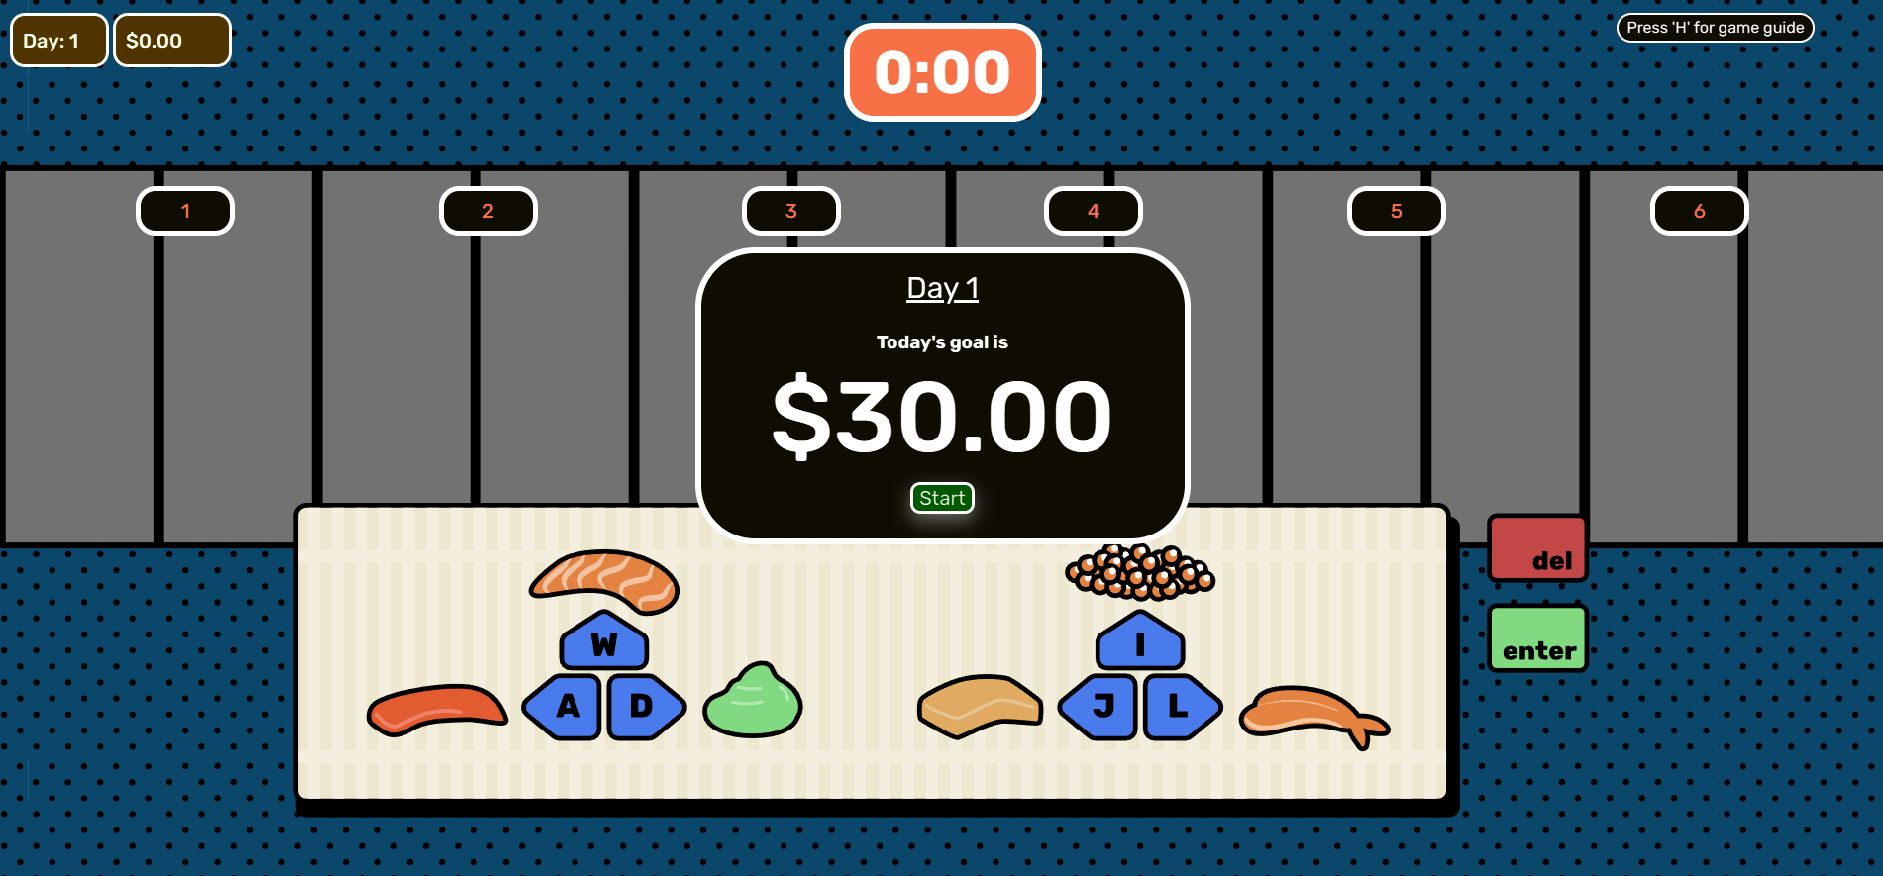

Starting screen

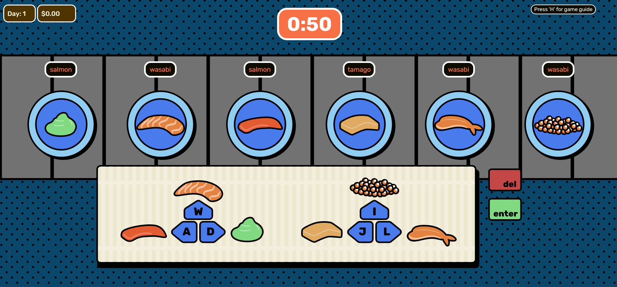

Press 'H' to toggle guide

